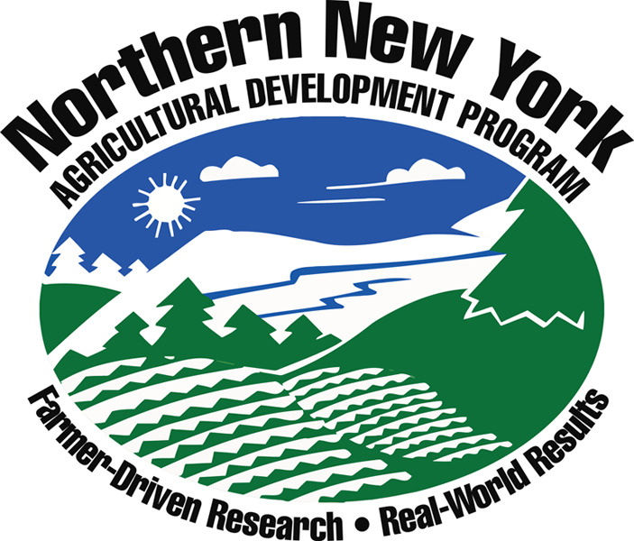

NNYADP Research Ideas 2020

DAIRY
- Evaluating calf housing and impact on calf respiratory disease.
- Impacts of thermal stress (cold and hot weather) on nutrient needs of calves and lactating animals in NNY and how it impacts productive parameters.
- Air quality regulations and potential programs.
- Culling: what new practices/techniques can be applied to improve decision-making (e.g., genetic testing)
- Rework cost of raising replacements in NNY.
- Feed efficiency, rumen/gut development in ad lib and acidified milk/MR fed calves.
- Lameness and cow comfort.
- On-farm water quality and impact of water quality on production parameters.
- Replacement management training—calf to breeding age.
- Herdspersons schools and milker training.
- Automation of health and reproductive management – what new technologies are available for dairy farms, how can we simplify management through the use of technology, economics of newest technologies?
- User friendly decision-support tools to facilitate farm economic decision-making: what is the best management strategy from an economic perspective. Develop tools that can deal with interactions between different areas of managements – health, nutrition, repro, genetics, etc.
- Impact of integrated reproductive management strategies (not just synch protocols) on whole herd repro performance and economic impact on farm profitability.
- Impact of heat stress on dairy management practices: What mitigation practices can NNY implement?
- Calf nutrition: How should we be feeding our calves in the winter time? Evaluating 3X a day feeding, additional calories, and other management strategies for cold weather.
- Impact of bedding type (specifically manure solids) on milk quality & cow comfort. Impact of what goes into the digester on solids composition, and milk quality.
- Digesters: continue to evaluate economic returns. What other “feedstuffs” can be used in a digester and what is the impact (ex: silage, whey, food waste).
- Mastitis treatment triage.
- Mastitis: continue to look into what is causing problems on NNY farms, economic impact of mastitis.
- Evaluate antibiotic usage on NNY dairy farms: what are the problems?
- Develop protocols and SOPs for common ailments on dairy farms: evaluate changes in antibiotic usage and herd health.
- Other relevant issues that would be beneficial for producers in NNY.

FIELD CROPS
- Test whether alfalfa winter survival scores from a test developed in the Midwest for characterizing alfalfa varieties predicts winter survival for NNY producers.
- Identify perennial grass species that are less competitive in a mixture with alfalfa.
- Alfalfa seeding rate trials: Are we planting enough seed?
- Evaluate the production of low lignin alfalfa varieties in NNY: are they suitable for NNY-specific growing conditions.
- Evaluate a system of pre-harvest estimation of mixed stand NDF in alfalfa grass mixtures.
- Postharvest evaluation of alfalfa grass species composition for evaluating: a) when to start treating the field as a grass stand from a fertilizer standpoint, when to consider rotating the field and b) to assess stand deterioration due to Alfalfa Snout Beetle.
- What grass species will withstand weather swings and thrive in NNY?
- What warm season perennials might be adaptable to NNY?
- Corn, soybean, small grain, alfalfa, annual forage crop variety trials.
- Research/demonstrations of new and improved alfalfa grass mixtures for NNY. Are there alternatives to the standard recommendations that might improve yield and quality? (Example: less aggressive grasses like non-heading orchard grass and meadow fescue).
- Alternative cash crops that may be viable in NNY- malting barley, hybrid rye, hops.
- Double forage crops to increase production and reduce risk: economic considerations, species, planting date nutrient management for optimal yield and forage quality.
- Identify annual warm season forage options: species, planting date, nutrient management etc.
- Research/demonstrations on the benefits of management-intensive grazing for dairy, beef and sheep.
- Snout beetle management, including a means for getting farmers more involved.
- Test well adapted and high yielding Alfalfa Snout beetle-resistant alfalfa varieties
- Determine experimental populations of resistant strains that are high yielding in ASB- infested fields.
- Determine yield potential of strains developed from plants that survived in a field inoculated with Brown Root Rot.
- Continue on-farm biocontrol nematode plots for controlling Alfalfa Snout Beetle.
- Control of corn rootworm with entomopathogenic nematodes in corn.
- Develop alternative methods for the application of biocontrol nematodes to fields in NNY.
- Monitor insect pressure, damage and treatment in NNY forage and grains.
- Assess disease pressures and timing in NNY corn and soybeans.
- Weed control for field crops – economics and yield data.
- Evaluation of conventional herbicide programs for weed control in corn and soybeans.
- Cover crop termination trials- cultural, mechanical and chemical methods.
- Field crop insect pest management projects- monitor and control options.
- Evaluation of seed treatments for control of insects and diseases.
- Utilizing IPM practices to control weeds, insects and diseases in field crops under NNY conditions.
- Continue research in beneficial nematodes - the economic assessment with Alfalfa Snout Beetle.
- Identification of cover crop seed that can be planted together with corn and will germinate.
- Identify opportunities for increased energy efficiency in NNY crop production systems.
- Evaluate economic and environmental impacts in all crop research.
- Can we recover any of the dry matter left in field after corn grain harvest?
- Seed coated rye, a cover crop for timed germination?
- Cover crop seed mixtures- what species and seeding rates should be used in NNY?
- Guidelines on warm season pasture/grazing options for NNY
- Wrap evaluations, number of times around bales? Color consideration? What makes a better bale for the application?
- Digestibility of BMR forage sorghum – what is the feed value?
- Continue work on demonstrating the value of tiling
- Are strip till and no till cropping systems viable in NNY?
- Land application of whey – what is the on NNY farms impact?
- Continue topics: preventing soil compaction, soil erosion, improve soil health, developing winter spreading guidelines.
- Proper use of manure spreading plans, incorporation of manure into the soil, rates of application.
- Cover crop- impact on nutrient losses and assessment of contributions to soil health.
- Developing strategies for successful cover crop establishment in NNY.
- Development of no-till hay or pasture establishment guidelines: impact on erosion and nutrient losses.
- What are the potential benefits of precision agriculture and use of drones in NNY crop production?
- Continue work to increase production of organic grains for local processing and to meet local food demand.
- Evaluation of soil amendments for improved crop production in NNY.
- Nutrient mass balances that work well on NNY farms.
- Evaluation of enhanced efficiency nitrogen sources used in agronomic crops in NNY.
- Test custom drag hose operations: how to minimize compaction and get higher silage yields in NNY. Would moving sand through them be feasible, given that sand bedding leads to less mastitis?
- Tile drainage and nutrient management: monitor nutrient loss through tile drains on various soils and on operating farms across NNY.
- Create a computerized soil management program based on recent nutrient management and soil health research.
- Evaluate manure application options to reduce losses and improve nutrient use efficiency.
- Develop methods to accurately predict crop nutrient requirements, enhance efficiency and protect soil and water resources.
- Is foliage fertilizer beneficial for agronomist crops on a larger scale in NNY?
- Follow up on initial studies with cover crops: yields/quality; application rate for manure; manure injection vs. surface tillage; impact of soil type, etc.
- Evaluate corn yield potential database on NNY farms.
- Test NDVI/Greenseeker technology to evaluate the nitrogen needs of corn and other crops grown in NY.
- Other relevant issues that would be beneficial for producers in NNY.

LIVESTOCK
- Develop dairy beef business in NNY.
- Increase value-added opportunities for livestock producers.
- Develop USDA-Graded Feeder Cattle markets to increase profitability.
- BQA: Beef Quality Assurance: work to promote this program more with producers.
- Identifying and selecting optimum dietary ingredients for NNY goat and sheep production.
- Internal parasite control for sheep and goats in NNY.
- What is an optimal grazing strategy for NNY for livestock?
- Develop no-till pasture seeding guidelines for NNY.
- Cost benefit analysis tools for converting from dairy to beef or other livestock production.
- Cover crops as emergency forage for harvest or grazing.
- Summer annuals for grazing.
- Research/demonstrations on benefits (increased gain) on improved pastures.
- Research/demonstrations on the benefits of management intensive grazing.
- Sheep for grazing in vineyards.
- Regional livestock marketing/infrastructure development.
- Conduct sheep and meat goat - feeding trials on farms.
- On a pasture system: wean lambs at 60 days vs 100 days?
- Creep feeding on pasture or not on pasture, labor, costs vs. increase gain?
- Other relevant issues that would be beneficial for producers in NNY.

LOCAL FOODS
- Evaluate the current marketing resources and needs in Lake Placid, Plattsburgh, Malone, Canton, Watertown and Lowville.
- Develop guidelines to be used by investors and granting agencies for each market region to evaluate proposal characteristics that have the best chance of success. Hold classes on “Types of
Cooperation/Organization” for farmers and marketers to facilitate the movement of food around the
NNY region.
3) Other relevant issues that would be beneficial for producers in NNY.

MAPLE PRODUCTION
  - Research on controlling native and non-native interfering vegetation in the sugarbush.
  - Research on 3/16 tubing yields under a gravity-based system and hooked up to a vacuum pump.
  - Maple tree regeneration-dealing with damage to sugarbush regrowth by deer.
  - Enhancing natural vacuum with smaller tubing.
  - Looking into maple decline and potential invasive insects in sugarbushes.
  - Climate change and tapping recommendations.
  - Feasibility of a bulk syrup processing facility.
  - Birch and walnut syrup production as complementary enterprises for maple producers.
  - Value added maple confections as a way to enhance maple sales.
  - Other relevant issues that would be beneficial for producers in NNY.

HORTICULTURAL CROPS
- Cold hardy grapes
  - Continue research, demonstration and outreach on variety testing, best management practices (trellising, canopy management etc.,) and business management for cold hardy grapes. Includes repurposing the Baker Farm vineyard and continuing to work with growers in the St. Lawrence and Champlain valleys.
  - Assess the economic impact of establishing vineyards, wineries and associate tourism on local and regional NNY economies.
  - Frost mitigation—both spring and fall.
  - Organic vineyards under NNY conditions.
  - Nutrient applications and management: what’s best under NNY soil and climate conditions?
- Adapt biocontrol nematode technology to other cropping systems: root weevils that attack all berries and black vine weevil that attacks ornamentals and stone, palm fruits (nematodes).
- Adapt biocontrol nematode technology to turf grass on golf courses.
- Season extension
  - Techniques to grow fruit/vegetables year around: crops beyond traditional tomatoes and winter greens; melons and other nontraditional crops for summer tunnels.
  - Advances in greenhouse and high tunnel production such as grafting on to cold hardy rootstocks and row covers inside tunnels.
  - Energy conservation in greenhouses: heat sinks, solar gain, insulation etc. (this is very important) More on appropriate use and management of caterpillar/low tunnels.
  - Adding light to tunnels—is it cost effective?
  - How to get vegetable crops to ripen earlier for fresh market sales.
- Fertility management for vegetables.
- Drip irrigation for increased yield and economic returns (also helpful for GAPs compared with overhead irrigation).
- Emerging pests and disease threats for NNY vegetable production
  - Dealing with unprecedented increases in disease and insect pests: both longstanding and invasive that are becoming commonplace.
  - Disease-resistant varieties suited for NNY’s cold climate.
  - Efficacy of organic pesticides, bio-pesticide products—side-by-side comparisons.
- Weed management in vegetable crops—conventional and organic. Reduce use of herbicides between rows in plasticulture systems; study feasibility of inter-row cover crop under NNY conditions.
- Soil amendment/improvement: soil amendment options; manure management; cover crop strategies for short rotations.
- Deer control.
- Food safety and post-harvest handling: designs in packing/post-harvest handling (GAPS, Coolbot).
- Enhancing pollination with the decline in honey bees and other pollinators.
- Cover cropping for weed management, fertility and control pests.
- Trail nematodes for garden slugs: Europe has a nematode-not allowed in U.S and trail predators for leek moths.
- June berries, honey berries: HASCAP requirements.
  - Table grapes: seedless for fall sales and for juice.
  - Wine grapes for jelly.
  - Emerging pest problems.
  - Continue with season extension of vegetables.
  - Continue supporting local marketing. What and how can I sell my produce, not just grow it?
- Pomme fruits with nematodes application in orchards to combat the plum curculio (control).
- Biological pest control (garden slugs).
- Predators for leaf moth (Canada).
- Honey Berries production (HASCAP).
- Pollination research for all insects, etc.
- Post-harvesting facility: materials, control temperature.
- GAP, food safety implementation for NNY farms.
- High tunnel: year’round growing, economics of cold season growing, not using energy and keeping it warm under NNY conditions.
- Cover crop for weed management.
- Hydroponics: LED lighting in enclosed buildings.
- Practical methods for in field measurement of nitrate, N.
- Conservation tillage/no-till production for vegetables.
- Other relevant issues that would be beneficial for producers in NNY.

