Northern NY Agricultural Development Program
2019-2020 Project Report

Increasing Syrup Production by Re-tapping Maples
within the Sap Season

Project Leader:
Adam D. Wild, Henry & Mildred Uihlein Director of the Uihlein Maple Research Forest,
Cornell University Maple Program, 157 Bear Cub Lane, Lake Placid, NY 12946;
518-523-9337; adw94@cornell.edu

Background:
Production yield of maple syrup is directly correlated with seasonal weather patterns and tapping procedures. Changes in climate have altered weather patterns during the maple tapping season and pose a threat of impacting maple producers’ yields.

Recent maple sugaring seasons have seen increased amounts of thawing earlier in the winter to be followed by extended freezes and later thaw-outs. For example, the 2018 maple season saw a thaw that allowed sap to run at the end of February but was followed with a cold period with slowed sap flow for a few weeks (Orefice, 2018).

This flux in weather across the maple season has extended the duration of the sap season and warmer weather earlier in the season can increase microbial growth, slowing the flow of sap in a tap hole. Producers are challenged to capture either early or late runs and must try to anticipate future weather patterns to optimize their sugar yield.

Maple producers who tap earlier in the season risk the chance of their tap hole drying up due to microbial plugging later in the season when the sap is still flowing. This can force a maple producer to consider re-tapping their trees to extend their production. However, solid evidence to support the effectiveness of this method was not previously available.

Producers who wait to tap risk missing out on early season high quality sap and productive runs that could be a significant portion of the sap season. Either scenario risks the chance of losing out on profits in a maple sugaring operation. Choosing the optimum time to tap is uncertain and it is impossible to predict weather patterns for the maple sap season.

Work done at the Uihlein Maple Research Forest in Lake Placid during the 2018 and 2019 maple syrup seasons looked at timing of tapping to best capture the most amount of sap (Figure 4). During this study it was found that trees tapped in late March did not yield as much syrup as they missed early sap runs. Trees tapped in January were able to capture early season sap runs but yield diminished slightly near the end of the season due to microbial plugging (Orefice, 2018). Based on this data, if a tree was re-tapped later in the sap season it could have the ability to increase syrup yield by 20%; a $3 increase in profit per tap.

If a maple producer were to tap earlier in the winter, they could come back later that same season and re-tap by moving the spout to a new tap hole or add an additional tap on a different drop line to capture maximum sap yields late in the season. This would allow a maple syrup producer to capture high levels of yield across the season. If the re-tapped hole were directly above the preliminary tap hole, less damage would be created within the tree by theoretically staying within the same stain column of wood. However, not enough data has previously been collected to determine whether the effort and added cost of re-tapping would bring a return on the investment. Colder climate patterns of Northern New York present new challenges that have not been studied.
With funding from the Northern NY Agriculture Development Program, the feasibility of re-tapping maple trees during the sap season was tested in 2019 and 2020 at Cornell University’s Uihlein Maple Research Forest in Lake Placid, NY. This report summarizes that project.

Methods:
Four treatments (Table 1.) were applied to evaluate the feasibility of re-tapping maple trees during the sap season in 2019 and 2020 at Cornell University’s Uihlein Maple Research Forest in Lake Placid, NY. Each treatment was replicated three times with five trees tapped for each treatment per replicate. All trees were under vacuum with only one tap per tree except for the treatments that were re-tapped later in the season. Each tree was tapped using 5/16-inch spouts and tubing. Spouts were brand new each season while lateral and dropline tubing had been used for three seasons prior to the start of the project. Installing used tubing was intentional to replicate a more realistic scenario of a sugarbush and would provide a higher inoculation of microbes later in the season.

Treatment 1 was tapped February 4 (2019) or January 22 (2020) and then pulled and tapped into a new tap hole drilled 8 inches above the initial tap hole (Figure 1) on April 15 (2019) or March 30 (2020). This new tap was into new wood that had not been compartmentalized into a dead zone and, in theory, did not create further damage within the tree. During the following growing season, the tree would compartmentalize this area of the tree creating a dead zone. Re-tapping was initiated when the slightest reduction in sap flow was noticed (drastically different each season).

Treatment 2 was also tapped February 4 (2019) or January 22 (2020) with an additional tap hole added directly above on April 15 (2019) or March 30 (2020) (Figure 1). In this treatment the original spout stayed within the original tap hole and a second spout with its own dropline was added to the new tap hole.
Treatments 3 and 4 were considered control treatments. Treatment 3 was tapped February 4 (2019) or January 22 (2020), the same times as Treatments 1 and 2 but was not re-tapped later in the season. Treatment 4 was tapped later in the winter on March 1 (2019 & 2020). This treatment ran the risk of missing potentially-earlier season sap runs, particularly in 2020, but could flow better later in the season. Sap volume and sap sweetness were captured for each replicated treatment each time the sap ran.

Table 1: Breakdown of experimental treatments; Increasing Syrup Production by Re-tapping Maples within the Sap Season, NNYADP 2019-2020 Project.

 | Method
Treatment 1 | Trees tapped February 4 (2019) or January 22 (2020). Original tap pulled and inserted into a new tap hole directly above initial tap, just before sap flow slowed (April 15 in 2019 and March 30 in 2020).
Treatment 2 | Trees tapped February 4 (2019) or January 22 (2020) and tap left in the tree all year. Additional tap added directly above initial tap, just before sap flow slowed (April 15 in 2019 and March 30 in 2020).
Treatment 3 | Trees tapped February 4 (2019) or January 22 (2020) and left in all season.
Treatment 4 | Trees tapped on March 1 (2019 & 2020) and left in all season.

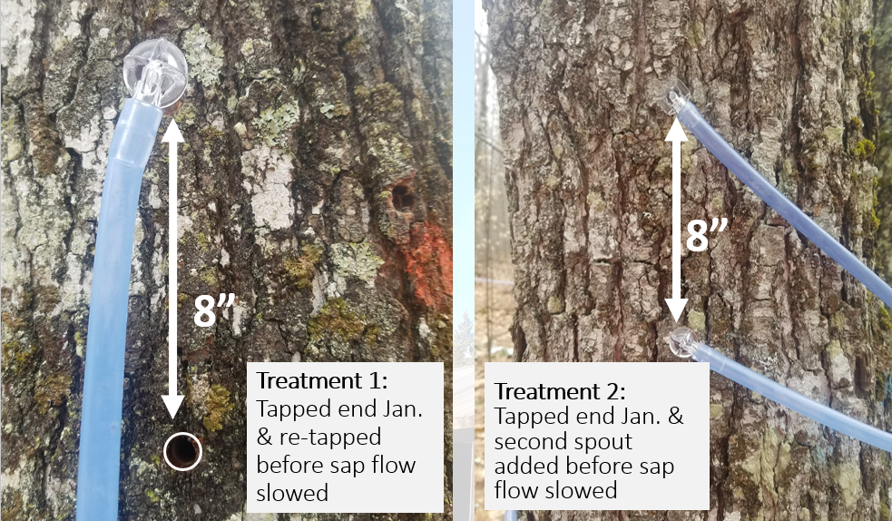Figure 1: Treatment 1 (left) had the spout removed from the tap hole before sap flow slowed (April 15 in 2019 and March 30 in 2020) and moved 8 inches up to a new tap hole. Treatment 2 (right) used a second drop line with a new spout added into a new tap hole before sap flow slowed (April 15 in 2019 and March 30 in 2020) 8 inches above the initial spout tapped in early February. Increasing Syrup Production by Re-tapping Maples within the Sap Season, NNYADP 2019-2020 Project.
Results:
The sap flow season of 2019 had a couple of small warm-ups, starting in early February, that were not significant. Actual heavy sap flow did not start until later in March and ended by April 19, barely lasting 5 weeks.

Results of the study from 2019 at the Uihlein Maple Research Forest showed that neither re-tapping trees into a new tap hole or adding a second spout later in the season was not effective for increasing syrup production (Figures 2 & 3). Instead, waiting to tap and limiting the time tap holes were left open proved to be more effective. Oddly enough, the most amount of syrup per tap was produced by control Treatment 4 when the trees were tapped on March 1 and not re-tapped; a 25% increase in syrup production over trees tapped in early February and not re-tapped (Treatment 3).

Treatment 2: trees that had a second dropline and spout added near the end of the season was the second best treatment with an 18.5% increase in syrup production over trees that were tapped at the same time but were not re-tapped late in the season.

Treatment 1 in which the spout was pulled near the end of the season and inserted into a brand new tap hole produced 5% less syrup per tap even though the spout was in a brand new tap hole the last few days of the season. The reduction in sap production could be a result of the old tap hole acting as a vacuum leak as the old tap hole was not plugged. However, no loss in vacuum was observed.

Results in 2020 were slightly different than in 2019 but showed similar trends. Significant sap flow started a month sooner in 2020 (end of February compared to end of March in 2019) yet lasted a couple of days longer than the 2019 season. This extension in the heavy maple sap flow season in 2020 was perfect for testing re-tapping.
Again in 2020, the most amount of syrup per tap was produced when we waited to tap the trees on March 1(Treatment 4), producing 29% more syrup per tap than trees tapped on January 22.

Different in 2020 was that trees tapped on January 22 and then had a second, new tap added on March 30, just before sap flow slowed (Treatment 2), produced equal amounts of syrup per tap as Treatment 4 (28% more syrup per tap than not re-tapping). However, even during this longer season, the added work and supplies did not yield more syrup per tap than just waiting to tap (Table 2). Instead, a negative gain in value is created once time and materials are factored in.

Pulling the spout before sap flow slowed and moving it to a new tap hole (Treatment 1) provided 19% more syrup per tap than not re-tapping but was not as productive as waiting to tap just as the season got underway. When the spouts were pulled and inserted into a new tap hole, loss in vacuum from the old, open tap hole was witnessed.

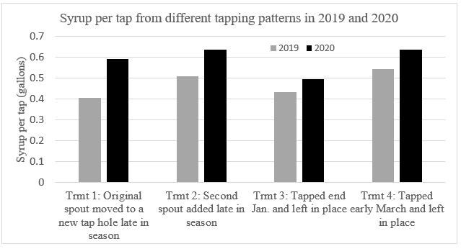Figure 2: Average syrup production per tap under differing re-tapping (Treatments 1 & 2) and control treatments (Treatments 3 & 4) at the Cornell University Uihlein Maple Research Forest in 2019 and 2020. Refer to Table 1 for full treatment descriptions. Increasing Syrup Production by Re-tapping Maples within the Sap Season, NNYADP 2019-2020 Project.

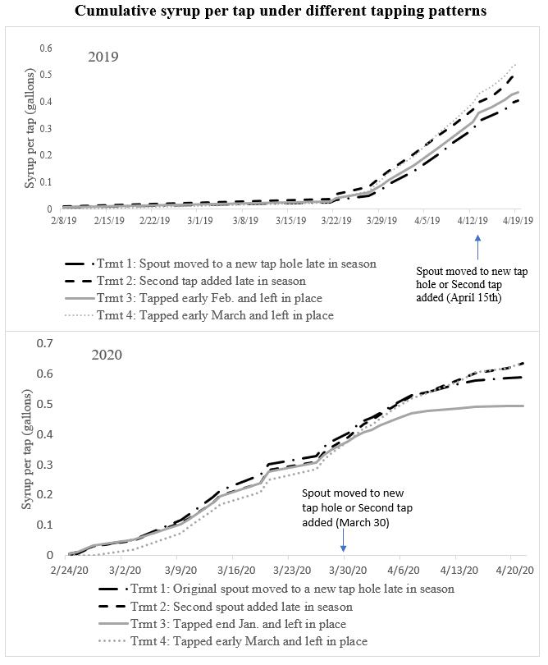
Figure 3: Cumulative maple syrup yield per tap under different tapping patterns at the Cornell University Uihlein Maple Research Forest in 2019 & 2020. Black lines (Treatments 1 & 2) represent trees that were re-tapped near the end of the season. All trees were tapped on February 4 (2019) or January 22 (2020) except for Treatment 4: trees were tapped March 1. In Treatment 1 the spout was pulled and inserted into a new tap hole 8 inches directly above the initial tap hole just before sap flow slowed. In Treatment 2 a second spout and dropline were added 8 inches above the existing spout just before sap flow slowed. Treatments 3 and 4 (gray lines) acted as controls that were not re-tapped but tapped at different times. Increasing Syrup Production by Re-tapping Maples within the Sap Season, NNYADP 2019-2020 Project.
Discussion:
At the conclusion of this study, the results were not as expected. Even the longer maple season of 2020 did not prove to show a huge benefit of re-tapping. Although going back and re-tapping by adding a second dropline with a new spout produced an average of 23% more syrup per tap, once time and material were factored into the equation, there was a loss of $0.73 per tap (Table 2). The added material includes a new spout ($0.20), dropline tubing ($0.25), and an additional T-fitting ($0.30). Although the dropline and T-fitting could be used for a few seasons, there is still added time and that dropline must be capped off completely to prevent vacuum loss.

When we waited to tap the trees on March 1, despite missing a few runs, there was still 27% more syrup per tap, an additional $2.94 worth of syrup per tap than trees that were tapped at the end of January, without additional labor costs of going back out to re-tap (Table 2).

Pulling the spout and inserting into a new tap hole produced only 7% more syrup per tap on average across the two seasons. Although no additional materials were needed with this treatment, there were still added time costs. Once time costs were incorporated, there was a loss of $0.70 per tap by going back out to re-tap, less of a loss than adding the second spout. Pulling the spout and inserting into a new tap hole (Treatment 3) produced less syrup than trees not re-tapped in 2019, which lowered the two-year average. If you consider the longer 2020 season alone with an additional 19% syrup produced, an added value of $0.75 per tap was achieved after labor costs. Additional seasons of testing are needed to see if this increase in value holds true.

It is important to note that this research was tested on previously-used tubing (new spouts each season), which is more than likely why the later tapping of trees was more effective than either of the re-tapping procedures. Using new tubing would more than likely produce different results. However, having new tubing is not feasible each year and this study more than likely represents a realistic application. The results of this research further emphasize the importance of preserving tap hole cleanliness as a best management practice.

Similar results were seen in our 2018 and 2019 timing of tapping research where we tapped trees in January, end of February, and late March. Within this study we found that trees tapped at the end of February (close to March 1) had the highest production in sap, however, trees tapped in later January were not significantly different in their production volume (Figure 4). The primary reason for not having a production difference is that this study was performed on tubing that was brand new in 2018. Trees tapped in late March missed out on runs and were not as productive (Figure 4).

Although our research showed more syrup per tap was achieved by waiting to tap on March 1 in Northern New York, I realize that this is not realistic for most maple operations of any substantial size. Even maple operations with 1,000 taps need to start tapping weeks prior to the start of the season to ensure taps are in before the season starts. As an alternative to re-tapping, it is recommended to increase sanitary practices in tubing to limit microbe growth within any tap holes drilled well before the season starts. Although not tested in this study, check valve spouts would prevent back-flow of sap and microbes and presumably produce more sap per tap on trees tapped early. The additional $0.25 cost for the check valve spout is much cheaper than labor and material costs to go back out later in the season and re-tap.
A note about the regionality of this project: all this timing of tapping research was done within the Uihlein Maple Research Forest sugarbush in Lake Placid, NY, a northern forest with extremely cold winters, deep snowpack, and a maple season that starts later than southern maple-producing regions. In areas where heavy sap flow starts in January followed by intermittent freeze-thaw cycles, re-tapping could provide more of a benefit than in maple producing regions similar to Lake Placid.

Figure 4: Average syrup production per tap when trees were tapped at different time periods at the Cornell University Uihlein Maple Research Forest in 2018 and 2019. Tubing was new in 2018 and new spouts were used each year. Comparison of Sap Yields Per Timing of Tapping Schedules for Maple and Birch Syrup Production, NNYADP 2018-2019 Project.

Table 2: Comparison of the increase in value created by tapping early and then re-tapping or waiting to tap right before the season started. The only situation where value is gained and not lost is when we waited to tap the trees right as the season was starting. Note that this was tested on used tubing; no cleaning or check valve spouts were used. Presumably, different results would be achieved if different sanitation methods were used. Increasing Syrup Production by Re-tapping Maples within the Sap Season, NNYADP 2019-2020 Project.
Increase in value of different tapping patterns tested
 | Trmt 1: Original spout moved to a new tap hole late in season | Trmt 2: Second spout added late in season | Trmt 3: Tapped end Jan. and left in place | Trmt 4: Tapped early March and left in place
Average gallons syrup per tap in 2019 & 2020 | 0.498 gal. | 0.572 gal. | 0.464 gal. | 0.590 gal.
Additional gallons of syrup per tap than trees tapped at the end of Jan. | 0.034 gal. | 0.108 gal. | ---- | 0.126 gal.
Additional pounds of syrup per tap than trees tapped at the end of Jan. | 0.38 lb. | 1.20 lb. | ---- | 1.40 lb.
Value of additional syrup @ US$2.10/lb | $0.80 | $2.52 | ---- | $2.94
Estimated additional labor cost to re-tap* | $1.50 | $2.50 | $0 | $0
Added material cost to re-tap** | $0 | $0.75 | $0 | $0
Total added value of re-tapping after time and material | $-0.70 | $-0.73 | $0 | $2.94

*Based on a value of $30 an hour with an estimate of 3 minutes to pull a spout and insert into a new hole and 5 minutes to add an additional dropline with a new spout and tap into a new hole.
**Added material costs for adding a second dropline and spout; includes costs of a new spout, dropline tubing, and a T-fitting.

Conclusions:
Due to the additional costs, re-tapping was found not to be cost effective or worthwhile for maple producers in northern forests. Waiting to tap the trees closer to the start of the sap season showed to be more effective for increased sap production and did not require additional time or materials. At this time, it is not recommended to re-tap maple trees unless a clear slowdown of sap flow is observed. If a producer does re-tap, the recommendation would be to pull the spout and re-insert into a new tap hole. Although the increase in production may not be as high as adding an additional new spout, an added cost of additional materials would not be necessary. Instead of re-tapping, maple producers should consider sanitation practices that preserve tap hole cleanliness to prevent contamination of the tap-hole, such as check-valve spouts, new droplines, or cleaning, to achieve optimal sap production.

Education and Outreach:
The results of this NNYADP-funded maple timing of tapping research were presented by Adam Wild at:
- Tubing Workshop, Croghan, NY, September 2019;
- 2020 New York State Maple Conference, the largest gathering of maple producers in the world;
- Regional Maple Schools: Northern NY Maple Expo, St. Lawrence County, January 2020; Lewis and Jefferson County Winter Maple School, January 2020; Clinton, Essex, Franklin Counties Northeastern New York Maple Boot Camp, January 2020.

All of these opportunities provided contact with maple producers across all of Northern New York and the broader New York State, Northeast and national maple-producing regions. The Northern New York Agricultural Development Program was recognized as the project funding source during each presentation. Additionally, a results article was provided to the Maple News and a two-year analysis was provided to the American Maple Digest.

For More Information:
- Adam D. Wild, Uihlein Maple Research Forest, Cornell University, 157 Bear Cub Lane, Lake Placid, NY 12946, 518-523-9337, adw94@cornell.edu, www.cornellmaple.com

References:
Orefice, J. (2018). “Timing of tapping of maple, birch, in N. Adirondacks.” Maple Syrup Digest. June/July 2018, p 7.

Acknowledgements:
This project was made possible through funding support from the Northern New York Agricultural Development Program. Project installation and data collection were completed with help from Uihlein Maple Research Forest Maple Technicians Keith Otto and Ryan Nerp. Cornell University New York State Maple Specialist Stephen Childs and Cornell University New York State Extension Forester Peter Smallidge provided technical advice.

